Reffered from that link:- search on google = “redhat cgroup”

https://access.redhat.com/documentation/en-us/red_hat_enterprise_linux/6/html/resource_management_guide/sec-relationships_between_subsystems_hierarchies_control_groups_and_tasks

INTRODUCTION

Cgroups allow you to allocate resources — such as CPU time, system memory, network bandwidth, or combinations of these resources — among user-defined groups of tasks (processes) running on a system.
You can monitor the cgroups you configure, deny cgroups access to certain resources, and even reconfigure your cgroups dynamically on a running system.

The cgconfig (control group config) service can be configured to start up at boot time and reestablish your predefined cgroups, thus making them persistent across reboots.

By using cgroups, system administrators gain fine-grained control over allocating, prioritizing, denying, managing, and monitoring system resources. Hardware resources can be appropriately divided up among tasks and users, increasing overall efficiency.

HOW CONTROL GROUPS ARE ORGANIZED

Cgroups are organized hierarchically, like processes, and child cgroups inherit some of the attributes of their parents. However, there are differences between the two models.

- The Linux Process Model
All processes on a Linux system are child processes of a common parent: the init process, which is executed by the kernel at boot time and starts other processes (which may in turn start child processes of their own). Because all processes descend from a single parent, the Linux process model is a single hierarchy, or tree.

Additionally, every Linux process except init inherits the environment (such as the PATH variable) and certain other attributes (such as open file descriptors) of its parent process.

- The Cgroup Model

Cgroups are similar to processes in that:
- they are hierarchical
- child cgroups inherit certain attributes from their parent cgroup.

The fundamental difference is that many different hierarchies of cgroups can exist simultaneously on a system. If the Linux process model is a single tree of processes, then the cgroup model is one or more separate, unconnected trees of tasks (i.e. processes).

Multiple separate hierarchies of cgroups are necessary because each hierarchy is attached to one or more subsystems. A subsystem represents a single resource, such as CPU time or memory. Red Hat Enterprise Linux 6 provides ten cgroup subsystems, listed below by name and function.
Available Subsystems in Red Hat Enterprise Linux

- blkio — this subsystem sets limits on input/output access to and from block devices such as physical drives (disk, solid state, or USB).
- cpu — this subsystem uses the scheduler to provide cgroup tasks access to the CPU.
- cpuacct — this subsystem generates automatic reports on CPU resources used by tasks in a cgroup.
- cpuset — this subsystem assigns individual CPUs (on a multicore system) and memory nodes to tasks in a cgroup.
- devices — this subsystem allows or denies access to devices by tasks in a cgroup.
- freezer — this subsystem suspends or resumes tasks in a cgroup.
- memory — this subsystem sets limits on memory use by tasks in a cgroup and generates automatic reports on memory resources used by those tasks.
- net_cls — this subsystem tags network packets with a class identifier (classid) that allows the Linux traffic controller (tc) to identify packets originating from a particular cgroup task.
- net_prio — this subsystem provides a way to dynamically set the priority of network traffic per network interface.
- ns — the namespace subsystem.
- perf_event — this subsystem identifies cgroup membership of tasks and can be used for performance analysis.

Note:-

You may come across the term resource controller or simply controller in cgroup literature such as the man pages or kernel documentation. Both of these terms are synonymous with “subsystem” and arise from the fact that a subsystem typically schedules a resource or applies a limit to the cgroups in the hierarchy it is attached to.
The definition of a subsystem (resource controller) is quite general: it is something that acts upon a group of tasks, i.e. processes.

RELATIONSHIPS BETWEEN SUBSYSTEMS, HIERARCHIES, CONTROL GROUPS AND TASKS

Remember that system processes are called tasks in cgroup terminology.

Here are a few simple rules governing the relationships between subsystems, hierarchies of cgroups, and tasks, along with explanations of the consequences of those rules.

Rule 1

A single hierarchy can have one or more subsystems attached to it.

As a consequence, the cpu and memory subsystems (or any number of subsystems) can be attached to a single hierarchy, as long as each one is not attached to any other hierarchy which has any other subsystems attached to it already (see Rule 2).

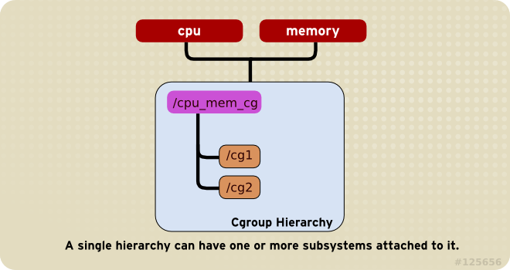

Rule 2
Any single subsystem (such as cpu) cannot be attached to more than one hierarchy if one of those hierarchies has a different subsystem attached to it already.

As a consequence, the cpu subsystem can never be attached to two different hierarchies if one of those hierarchies already has the memory subsystem attached to it. However, a single subsystem can be attached to two hierarchies if both of those hierarchies have only that subsystem attached.

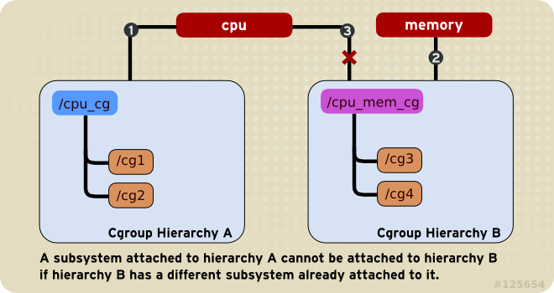

Rule 3:-

Each time a new hierarchy is created on the systems, all tasks on the system are initially members of the default cgroup of that hierarchy, which is known as the root cgroup. . For any single hierarchy you create, each task on the system can be a member of exactly one cgroup in that hierarchy. A single task may be in multiple cgroups, as long as each of those cgroups is in a different hierarchy.

he cgroup in cpu_mem_cg that the httpd process is a member of might restrict its CPU time to half of that allotted to other processes, and limit its memory usage to a maximum of 1024 MB. Additionally, the cgroup in net that the httpd process is a member of might limit its transmission rate to 30 MB/s (megabytes per second).

When the first hierarchy is created, every task on the system is a member of at least one cgroup: the root cgroup. When using cgroups, therefore, every system task is always in at least one cgroup.
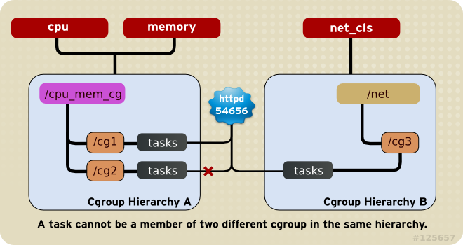

Rule 4:-
Any process (task) on the system which forks itself creates a child task. A child task automatically inherits the cgroup membership of its parent but can be moved to different cgroups as needed. Once forked, the parent and child processes are completely independent.

As a consequence, consider the httpd task that is a member of the cgroup named half_cpu_1gb_max in the cpu_and_mem hierarchy, and a member of the cgroup trans_rate_30 in the net hierarchy. When that httpd process forks itself, its child process automatically becomes a member of the half_cpu_1gb_max cgroup, and the trans_rate_30 cgroup. It inherits the exact same cgroups its parent task belongs to.

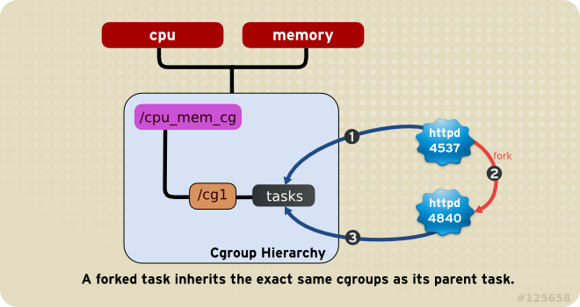

USING CONTROL GROUPS

Control groups and the subsystems to which they relate can be manipulated using shell commands and utilities. However, the easiest way to work with cgroups is to install the libcgroup package, which contains a number of cgroup-related command line utilities and their associated man pages.

It is possible to mount hierarchies and set cgroup parameters (non-persistently) using shell commands and utilities available on any system . However, using the libcgroup-provided utilities simplifies the process and extends your capabilities.

In order to use cgroups, first ensure the libcgroup package is installed on your system by running, as root:
~]# yum install libcgroup

The cgconfig Service:-

The cgconfig service installed with the libcgroup package provides a convenient way to create hierarchies, attach subsystems to hierarchies, and manage cgroups within those hierarchies. It is recommended that you use cgconfig to manage hierarchies and cgroups on your system.

The cgconfig service is not started by default on Linux 6. When you start the service with chkconfig, it reads the cgroup configuration file — /etc/cgconfig.conf. Cgroups are therefore recreated from session to session and remain persistent. Depending on the contents of the configuration file, cgconfig can create hierarchies, mount necessary file systems, create cgroups, and set subsystem parameters for each group.
The default /etc/cgconfig.conf file installed with the libcgroup package creates and mounts an individual hierarchy for each subsystem, and attaches the subsystems to these hierarchies. The cgconfig service also allows to create configuration files in the /etc/cgconfig.d/ directory and to invoke them from /etc/cgconfig.conf.
If you stop the cgconfig service (with the service cgconfig stop command), it unmounts all the hierarchies that it mounted.
2.1.1. The /etc/cgconfig.conf File
The /etc/cgconfig.conf file contains two major types of entries — mount and group. Mount entries create and mount hierarchies as virtual file systems, and attach subsystems to those hierarchies. Mount entries are defined using the following syntax:
mount {
subsystem = /cgroup/hierarchy;
…
}
The libcgroup package automatically creates a default /etc/cgconfig.conf file when it is installed. The default configuration file looks as follows:
mount {
cpuset = /cgroup/cpuset;
cpu = /cgroup/cpu;
cpuacct = /cgroup/cpuacct;
memory = /cgroup/memory;
devices = /cgroup/devices;
freezer = /cgroup/freezer;
net_cls = /cgroup/net_cls;
blkio = /cgroup/blkio;
}
The subsystems listed in the above configuration are automatically mounted to their respective hierarchies under the /cgroup/ directory. It is recommended to use these default hierarchies for specifying control groups. However, in certain cases you may need to create hierarchies manually, for example when they were deleted before, or it is beneficial to have a single hierarchy for multiple subsystems (as in Section 4.3, “Per-group Division of CPU and Memory Resources”). Note that multiple subsystems can be mounted to a single hierarchy, but each subsystem can be mounted only once. “Creating a mount entry” for an example of creating a hierarchy.
Creating a mount entry

The following example creates a hierarchy for the cpuset subsystem:
mount {
cpuset = /cgroup/red;
}
the equivalent of the shell commands:
~]# mkdir /cgroup/red
~]# mount -t cgroup -o cpuset red /cgroup/red
Since each subsystem can be mounted only once, the above commands would fail if cpuset is already mounted.
Group entries create cgroups and set subsystem parameters. Group entries are defined using the following syntax:
The following example creates a cgroup for SQL daemons, with permissions for users in the sqladmin group to add tasks to the cgroup and the root user to modify subsystem parameters:
When combined with the example of the mount entry in “Creating a mount entry”, the equivalent shell commands are:

~]# mkdir -p /cgroup/red/daemons/sql
~]# chown root:root /cgroup/red/daemons/sql/*
~]# chown root:sqladmin /cgroup/red/daemons/sql/tasks
~]# echo $(cgget -n -v -r cpuset.mems /) > /cgroup/red/daemons/cpuset.mems
~]# echo $(cgget -n -v -r cpuset.cpus /) > /cgroup/red/daemons/cpuset.cpus
~]# echo 0 > /cgroup/red/daemons/sql/cpuset.mems
~]# echo 0 > /cgroup/red/daemons/sql/cpuset.cpus
Note

You must restart the cgconfig service for the changes in the /etc/cgconfig.conf file to take effect. However, note that restarting this service causes the entire cgroup hierarchy to be rebuilt, which removes any previously existing cgroups (for example, any existing cgroups used by libvirtd). To restart the cgconfig service, use the following command:
~]# service cgconfig restart
When you install the libcgroup package, a sample configuration file is written to /etc/cgconfig.conf. The hash symbols ('#') at the start of each line comment that line out and make it invisible to the cgconfig service.
The /etc/cgconfig.d/ Directory
The /etc/cgconfig.d/ directory is reserved for storing configuration files for specific applications and use cases. These files should be created with the .conf suffix and adhere to the same syntax rules as /etc/cgconfig.conf.
The cgconfig service first parses the /etc/cgconfig.conf file and then continues with files in the /etc/cgconfig.d/ directory. Note that the order of file parsing is not defined, because it does not make a difference provided that each configuration file is unique. Therefore, do not define the same group or template in multiple configuration files, otherwise they would interfere with each other.
Storing specific configuration files in a separate directory makes them easily reusable. If an application is shipped with a dedicated configuration file, you can easily set up cgroups for the application just by copying its configuration file to /etc/cgconfig.d/.

